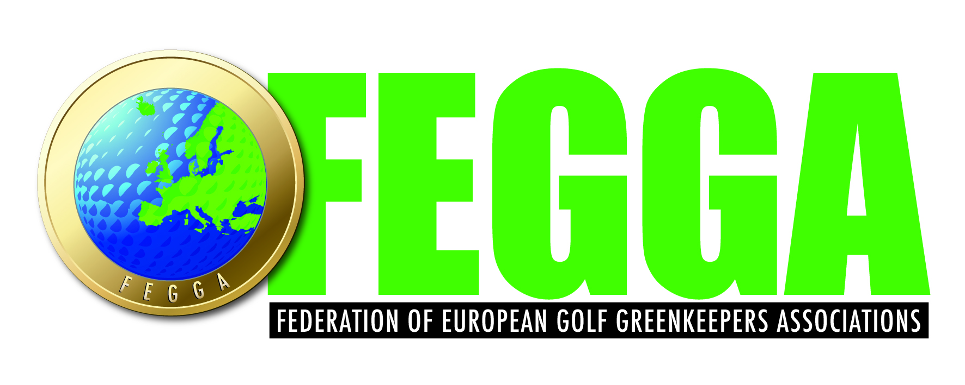
3 Riddell Close, Alcester, Warwickshire, B49 6QP, England

Tel: 0044 (0)1789 762912 E-mail: dean.cleaver@btinternet.com www.fegga.org

Contact:
Dean Cleaver
Executive Officer
Phone: 0044 (0)7813 921143
dean.cleaver@btinternet.com

Press Release:

International “Thank a Greenkeeper Day” honors golf course management professionals on Sept. 23
Golfers are asked to show their support on social media using #ThankAGreenkeeper

As a healthy outdoor activity that can adhere to social distancing, golf has seen a worldwide resurgence in the wake of the COVID-19 pandemic. On Sept. 23, the Federation of European Golf Greenkeepers Associations (FEGGA), in conjunction with other global Greenkeeper Association groups, is recognising those who help keep the game going and enjoyable with “Thank a Greenkeeper Day,” encouraging all those who love golf to thank their course’s greenkeepers.

In addition to FEGGA and its Member Associations, other groups taking part in the global event include the Australian Sports Turf Managers Association (ASTMA), the Canadian Golf Superintendents Association (CGSA), and Golf Course Superintendents Association of America (GCSAA). All together the groups represent more than 31,000 golf course management professionals in 78 countries around the world.

The celebration on Sept. 23 will include a commercial that will begin rotation on the Golf Channel and other media outlets, and social media messages touting the many ways that superintendents/greenkeepers make the game more enjoyable and sustainable. Golfers and others are encouraged to join in the conversation on social media using the hashtags “#ThankASuper” or “#ThankAGreenkeeper depending on their country’s nomenclature.

“Superintendents/greenkeepers work hard each day to provide the excellent playing conditions that add to the, enjoyment of the game,” said Rhett Evans, GCSAA Chief Executive Officer. “But in the face of the pandemic, they have played a key role in developing and maintaining the safety protocols that allow golfers to engage in their favorite sport while adhering to pandemic-related guidelines and restrictions.”

As courses reopened after the early months of the crisis, the demand for golf was clear. In the United States, golf rounds in June and July were up as much as 20% over the same time period in 2019, and in many parts of Europe, July rounds were up to as much as 40% - 60% over last year.

In addition to dealing with new pandemic procedures, greenkeepers continually strive to keep the game’s playing fields healthy and beautiful with environmental stewardship as a primary focus. Thanks to the overall efforts of the golf industry, golf courses are using less water, employing sustainable management practices and expanding natural wildlife habitats on courses.

Dean Cleaver of FEGGA commented; “Golf has been a major outlet to having some normality to people’s lives during the pandemic. It’s therefore fitting that we take a day to recognise the men and women who work behind the scene to provide this perfect escape. FEGGA is proud to join the many associations around the world by encouraging those who love golf and appreciate the work done by our dedicated greenkeepers to share their thoughts on social media to #ThankAGreenkeeper”

To learn more about FEGGA and the role it plays in the enjoyment and sustainability of the game, visit www.fegga.org

About FEGGA:

FEGGA is a non profit organisation formed in 1996 in Amsterdam, Netherlands. The Federation is the umbrella body for 23 National Greenkeeping Associations in Europe. FEGGA originally formed to be a communication medium between the Committed to Green Programme of the European Golf Association and European Greenkeeping Associations, the role of the Federation has expanded greatly since 1996.

FEGGA now plays an every-day role in our member associations through the promotion of educational standards and professional recognition along with the many issues facing greenkeepers concerning the European Union and EU legalisation.

Having built a network of contacts throughout Europe, the Federation is assisting promotion of the profession of golf turf management country by country, working with golf bodies, our patron members and other allied associations. Many benefits are now visible across Europe with educational programmes, environmental policies and general recognition of the profession.

Visit FEGGA at www.fegga.org, or find us on Facebook or Twitter.

Member Associations: Austria, Belgium, BIGGA, Bulgaria, Czech Republic, Denmark, Estonia, Finland, Germany, Hungary, Iceland, Rep. of Ireland, Italy, Netherland, Norway, Portugal, Russia, Serbia, Slovakia, Slovenia, Sweden, Switzerland.

Affiliate Member Associations: South Africa, GCSAA.

Patrons: Aquatrols, Barenbrug, Bayer, Belrobotics, Campey Turf Care, Club Car, Capillary Concrete, Culterra, Dennis-Sisis, EIGCA, EGCOA, Foley United,
Frank Newberry, Goldcrop, Grundfos, GTC, Harradine Golf, Herbatech, Hunter, Indigrow, John Deere, Kainuu College, Kristianstads Golfbana, Le Golf National, Moore Turf Care, Ransomes-Jacobsen, (re)GOLF, SISGrass, Sports Turf Maintenance Company, Steiner & Partner, Sustane, Symbio, Syngenta, Toro, Verschoor.

FEGGA is dedicated to communicate and share environmentally sustainable ideals and skills for quality Golf Course management

