SEMINAR AND CONFERENCE
The Czech Association of greenkeeperů 2016

Term: 20.1. to 21.1.2016

Location: Czech University of Life Scinces Prague – a circular Hall (Faculty of Engineering)

Accommodation:

College Czech University of Life Scinces Prague (order and pay everyone myself) the price for accommodations is $ 430.0-os / night: Tel. + 420 224 383,523 (reception: 3538)

fax.: + 420 234 381 856, email: mkurkova@kam.czu.cz, www. where. czu.cz, Kamýcká 1280, 165 00 Prague 6 – Suchdol,

Hotel Galaxy approx. 500 m from the "circular Hall"- Suchdolské us. (orders and shall be borne by each alone) -person in double room 500.0-CZK with breakfast buffet, a person in triple room 400.0-CZK with breakfast, a person in a single room-CZK 900.0, the Conference participants will log on yourself directly in the hotel at info@hotelgalaxie.cz, Suchdolské nám. 9, 165 00 Prague 6 – Suchdol, Tel.: + 420 220 921 234, fax: + 420 220 922 071, under the slogan : "greenkeeperský seminar and Conference"

Catering: the duration of the seminars and conferences (lunch 20.1. and 21.1., dinner 21.1.) ČSG
ČSG members have outside accommodation provided free of charge to all Conference and seminar in the framework of the membership fee.

Non-members ČSG pays the participation fee for the seminar 3.500,-CZK.

20.1.2016 the first day of the seminar
Prezence participants, 8 am.
The beginning of the seminar, 9 pm.

1) Jiri Benes-use GIS (mapping information system) for the maintenance of golf courses
2) Petr Novák (ČZU-TF) application of precision technology in terms of golf courses (soil Parameters, their measurement and sampling procedures, creating maps, guest maps, variable fertilization and its influence on the qualitative parameters of the lawns, remote sensing and its application, GIS and its application in terms of golf, robotics, and emerging technologies)
Presentation of the patrons of the ČSG
Lunch 1.30 pm.14.30 afternoon lectures. up to 4 pm.
3) Petr Novák (Port Richey golf course)-application of new technologies in the construction of a new golf course

20.1.2016 Conference ČSG 2016
Prezence participants, 16.30 pm
Conference 17.00 pm.
After the end of the Conference, dinner and social evening
21.1.2016 on the second day of the seminar
Morning lectures 9.00.
4) Aleix Masferrer (Spain) – PGA Catalunya Resort, focusing on the management of the
course (History, Maintenance Standard Objectives, Resources &
Future-Plans)"

5) Jiří Kapeš, Kamil Pečenka – preparation course on international professional tournament
Kaskáda golf course and Dýšina
6) Michael Cermak-2015 Season from the perspective of závlaháře.
7) Panel discussion : participants: Michal Čermák ITTEC , Dalibor Walk – CGF, Aleix Masferrer, Kamil Pečenka ČSG and other representatives of greenkeeperů from ČSG
Lunch 2 pm.
The expected conclusion, 3 pm

Information: according to the resolutions of the conferences held 10.1.2010 in Prague-Suchdol is the amount of the membership fee for regular members of the 2100,-CZK/year and the proportion of other membership according to the statutes of the ČSG. The membership fee can be paid in ČSG presence at the seminar.

Current information about the seminar and Conference 2016 you will find at: www.czgreen.com
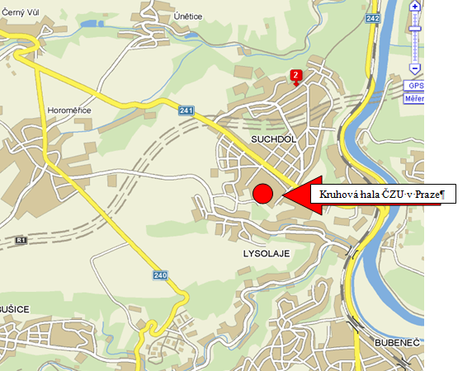
-----------------------------------------------------------------------------------------------------------------
APPLICATION

With eminář and Conference ČSG 2016

Czech Agricultural University in Prague – a circular Hall 20.1.-21. 1 2016)

Name and surname:.................................... Employer:.............................................

Contact address:......................................................................................................

E-mail : …………………………………………………………… Mobile phone:........................

Membership in the ČSG: Yes/No * form of payment: membership INVOICE/CASH *

Billing information: CORPORATE ID............................................................................................

adresa……………………………………………………………………………………………………..

V ………………………………. ………………………………… (signature)
the loop around the current state of the

